The system :

1. HARRIX ERP — MASTER STRUCTURE

USERS
↓
ROLES & PERMISSIONS
↓
HARRIX ERP
├── Dashboard
├── Inventory
├── Production
├── Sales
├── Suppliers
├── HR
├── Finance
├── Reports
└── Settings

USERS
↓
ACTIVITY LOG

2. USERS — ROLES — PERMISSIONS

OWNER
↓
Full access
↓
Can decide accountant permissions

ACCOUNTANT
↓
Restricted access
↓
Only sees authorized information

3. ACTIVITY LOG

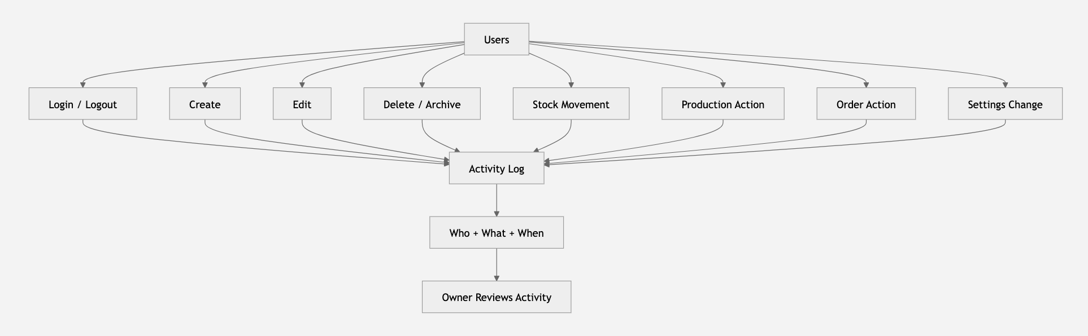

Exp:

Accountant
↓
Edited Chemical CH-024
↓
Activity Log
↓
27 Aug 2026 — 14:32

4. INVENTORY STRUCTURE

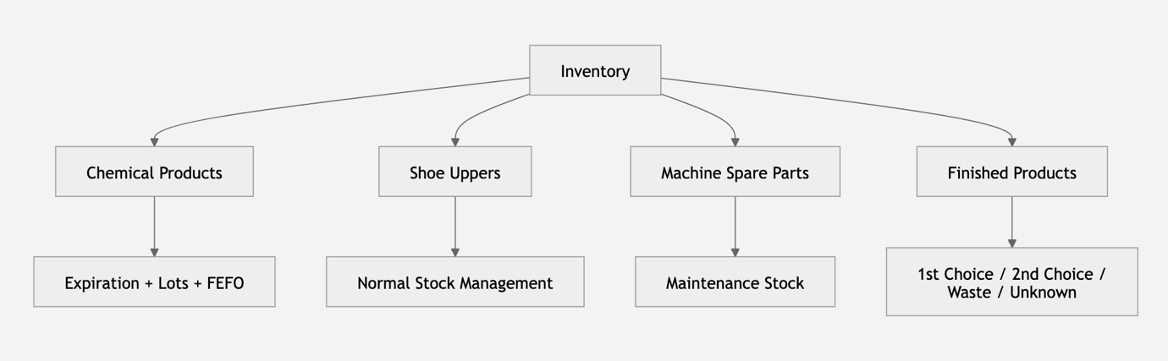

5. CHEMICAL FLOW

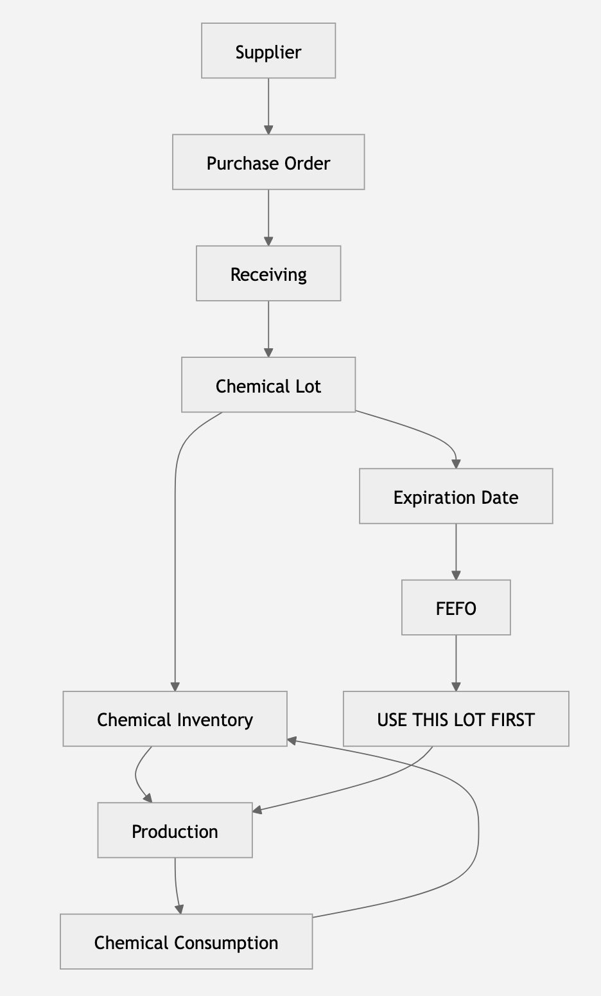

6. PRODUCTION — THE HEART OF HARRIX ERP

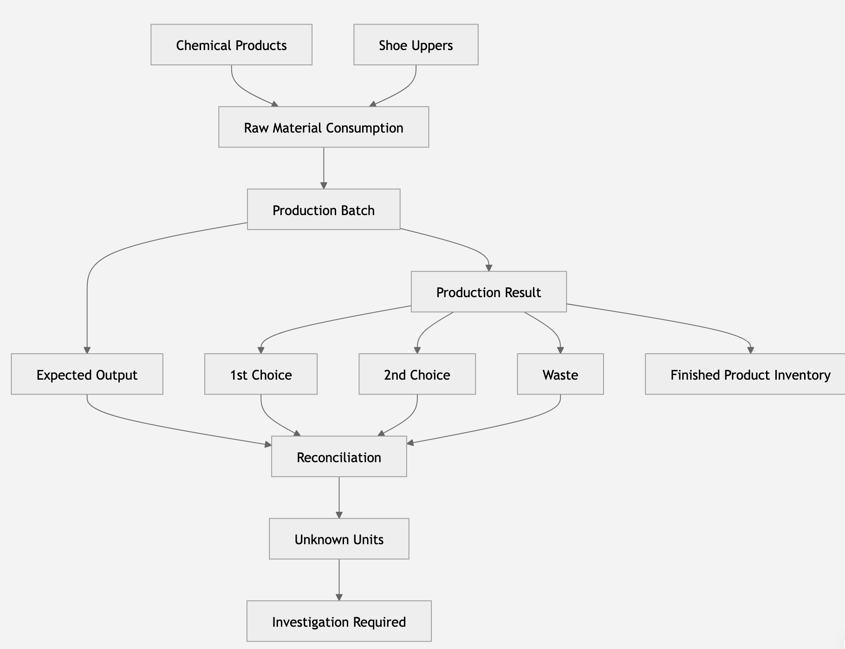

7. PRODUCTION → FINISHED PRODUCT → SALES

Production
↓
Finished Products
↓
Stock
↓
Customer Order
↓
Customer
↓
Revenue

8. SUPPLIERS → INVENTORY → PRODUCTION

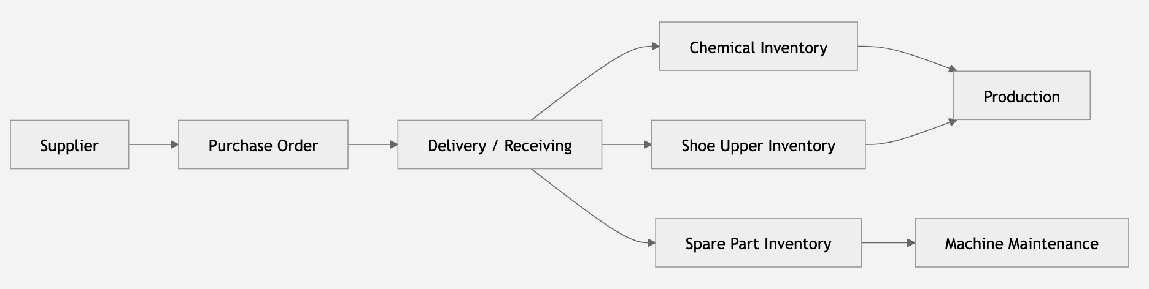

9. COSTING & SUGGESTED PRICE ( TO BE ADDED )

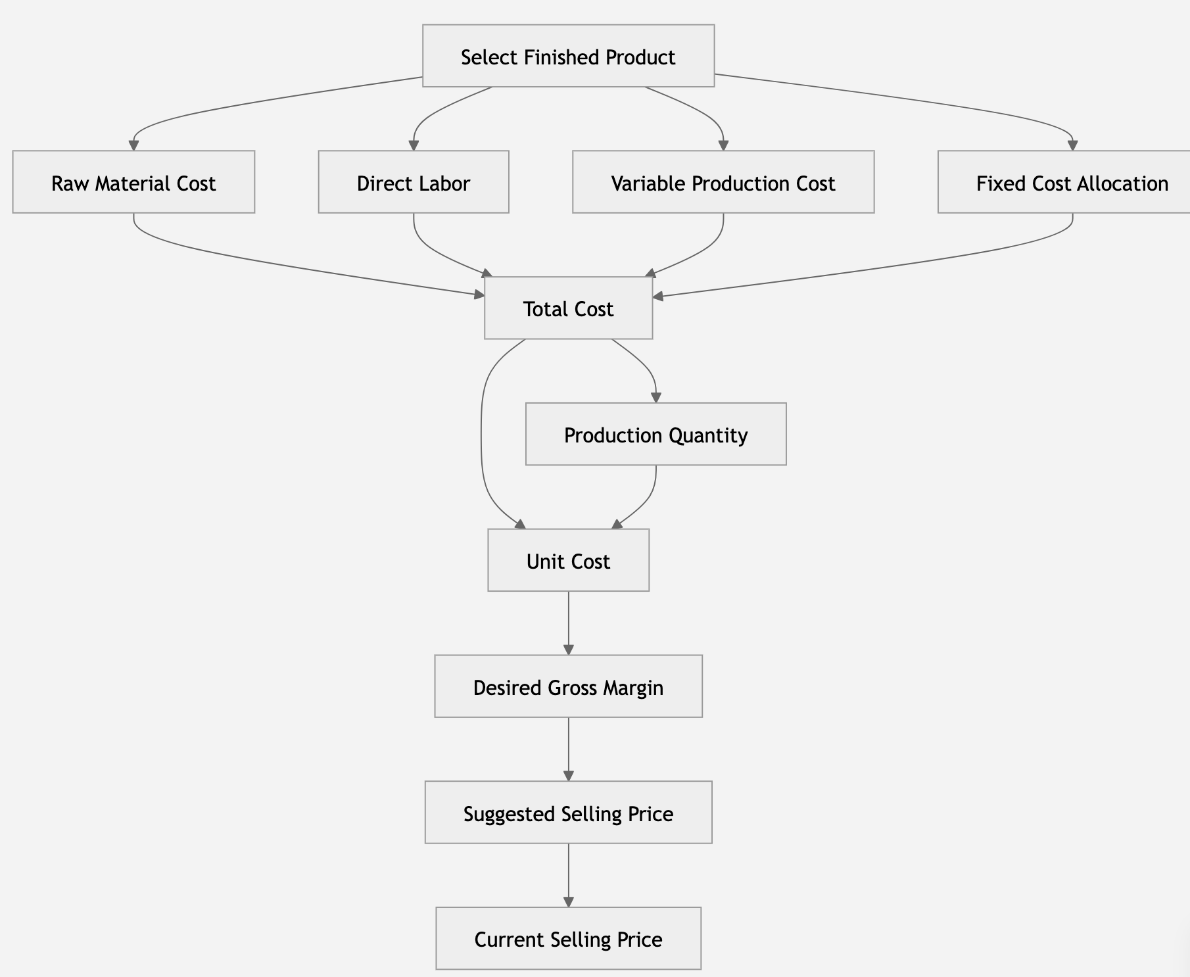

The logic:

SELECT PRODUCT
↓
ALL COSTS
↓
TOTAL COST
↓
QUANTITY
↓
UNIT COST
↓
DESIRED MARGIN
↓
SUGGESTED PRICE

Formula:

Unit Cost = Total Cost / Quantity

Suggested Price =
Unit Cost / (1 - Margin)

Exp:

Total Cost = 132,000 DZD
Quantity = 120

Unit Cost = 1,100 DZD

Margin = 30%

Suggested Price = 1,571.43 DZD

10. SALES → CUSTOMER → DASHBOARD

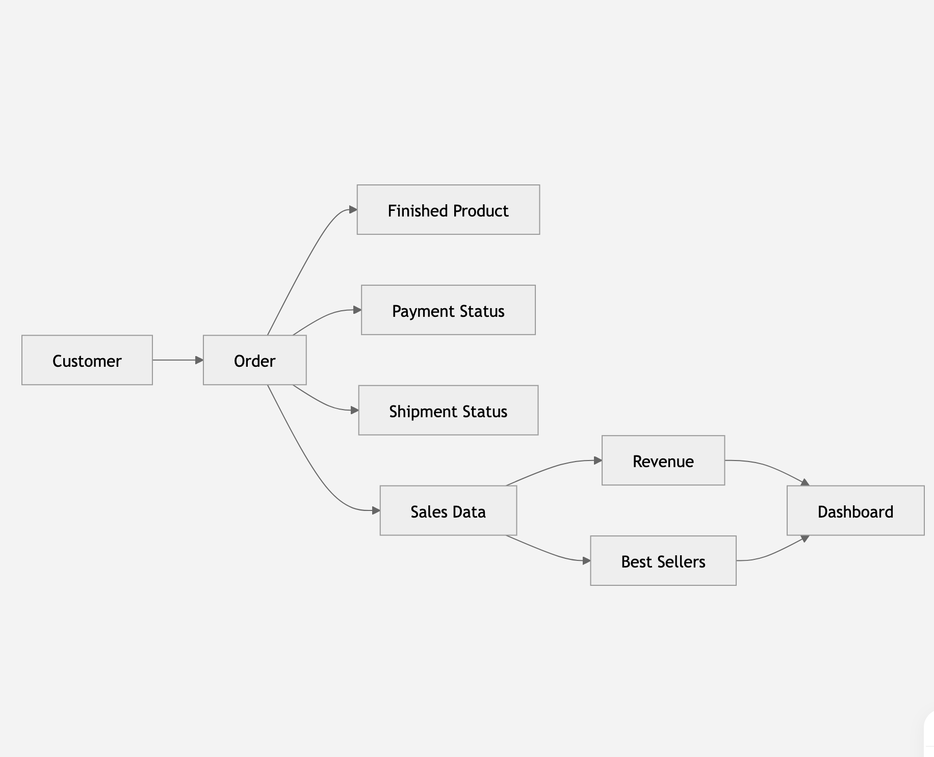

Summary:

this is the real essence of HARRIX ERP SHOES

USERS
↓
ROLES & PERMISSIONS
↓
HARRIX ERP
↓
┌─────────────┼─────────────┐
↓ ↓ ↓
INVENTORY PRODUCTION SALES
↓ ↓ ↓
MATERIALS → PRODUCTION → FINISHED PRODUCTS
↓
ORDERS
↓
CUSTOMERS

Then there are two parallel systems:

HARRIX ERP
│
┌───────────┴───────────┐
↓ ↓
FINANCE HR
↓ ↓
COST + MARGIN EMPLOYEES + ATTENDANCE
│
↓
DASHBOARD

HARRIX UPDATE:

- Dashboard: we should add smth like

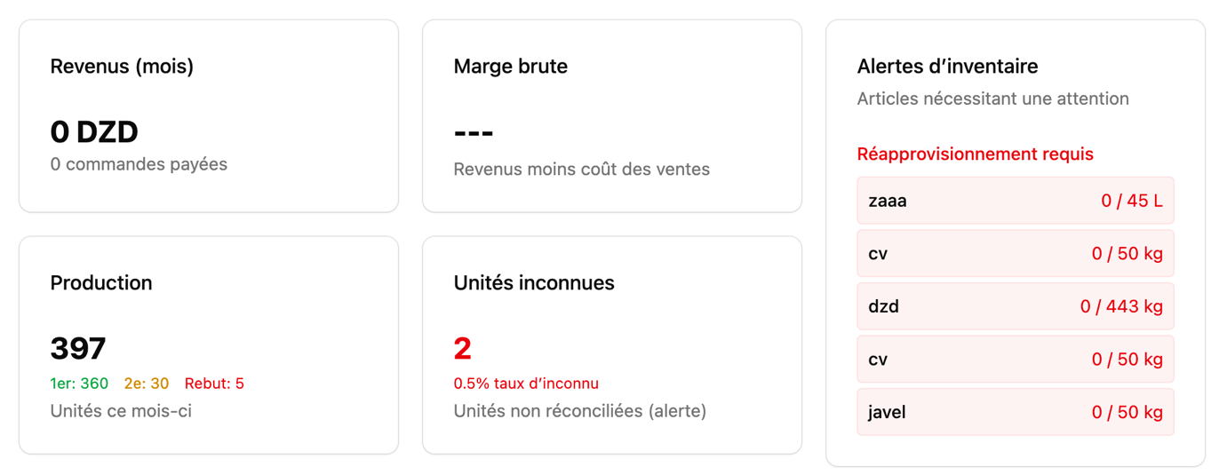
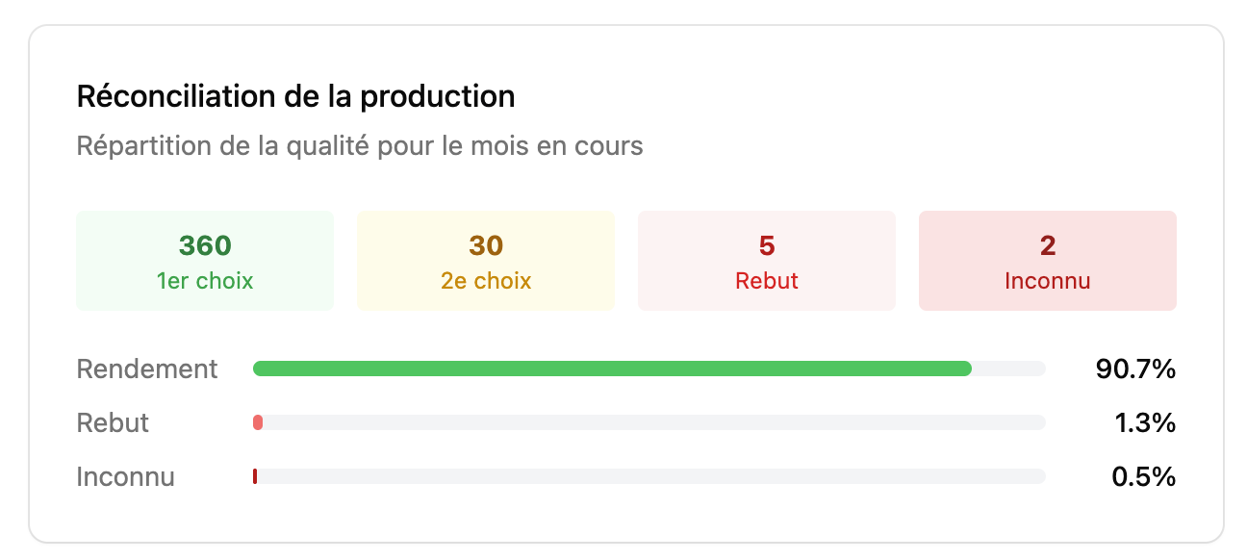

+ Sales statics (graph) “ Overview of sales data over selected periods “ : DAILY / WEEKLY / MONTHLY

+ Best sellers ( A list of best selling products ) to know which product that has to produce more

- Stock: we can add a “+” bottom if the user wants to add a new raw material , and that new raw material should work with the same system that the other raw materials work (except the chemical products (they work FEFO method) )

- Achat: in TAX section, the user should put only the % and the system calculates it auto
+ replace “cout unitaire (DZD)” by “prix unitaire (DZD)”
+ add “modify” option for “bon de commande” (when the statut is “bruillion”)
+ add “whatsapp” or “wechat” api’s to send the request directly to the supplier

- RH: when the user clicks on the name of the employee, he can see other details for example :
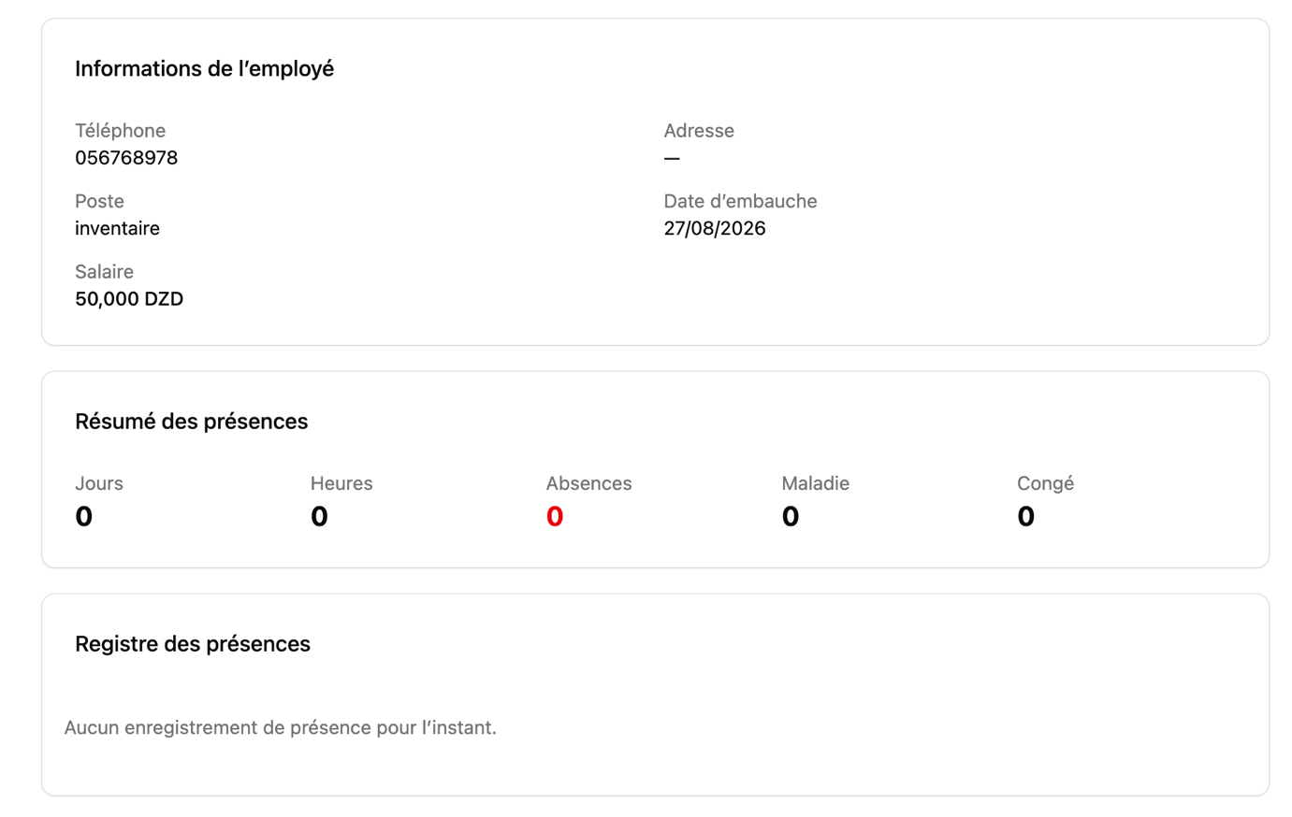
+ add “archive” option to archive an employee

- We should add “cost & price” section:

Add a cost tab with 2 sections: cost and price for the whole costs of the factory aswell in the stocks and production.

It could be smth like this:
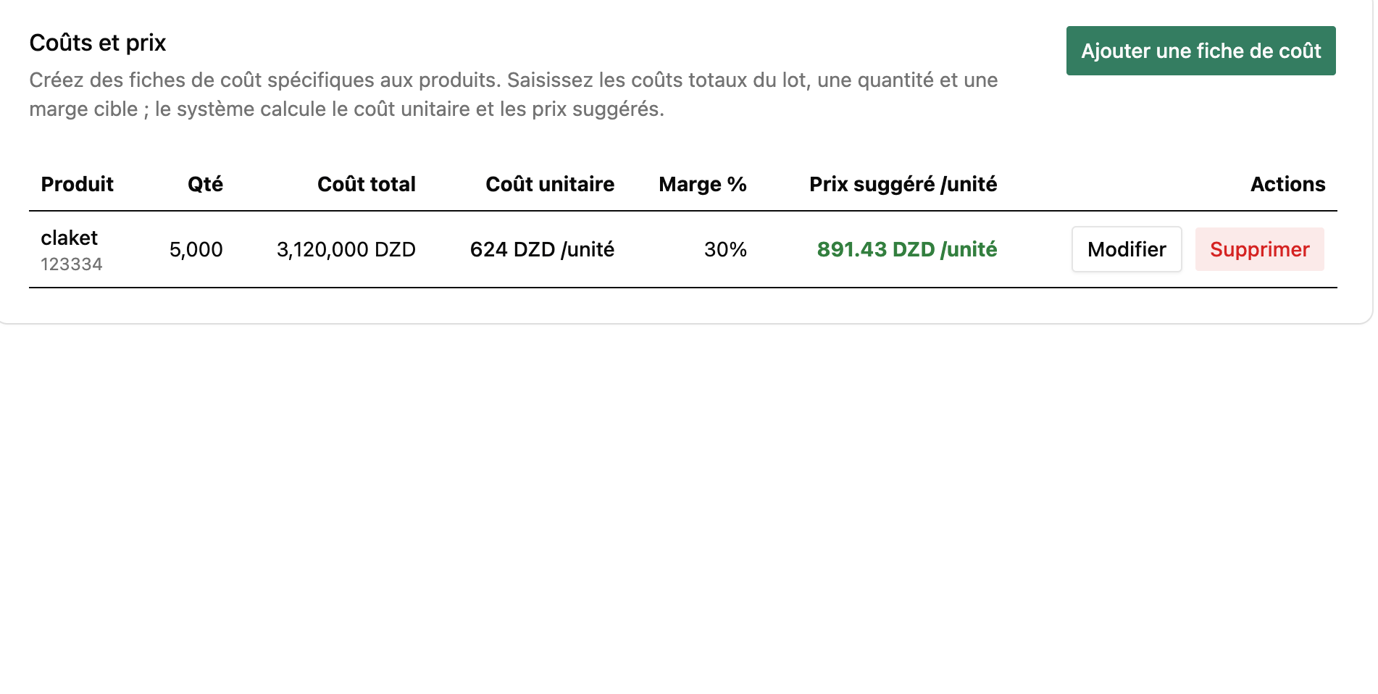
After selecting a specific finished product :
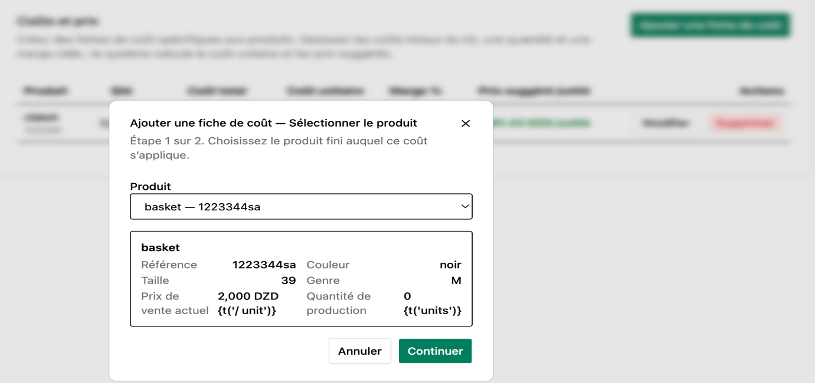

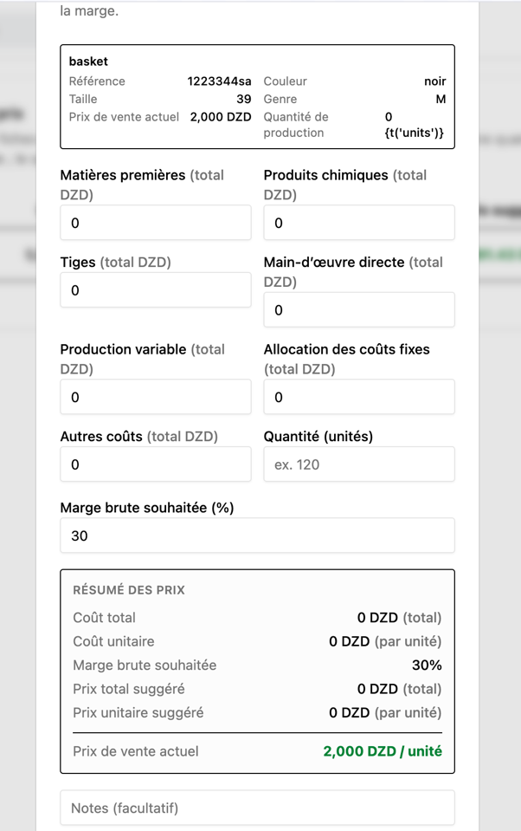

This option helps the user to see the price that he sells with and the real price that he should sell with to be in a good “santé financière”
if we can add also market section in which the user can see the price of his finished product how much does it cost, that would be better because this will help the owner to see his position in the market with his competitors

- When it comes to section bar:

We would make “achat&frs” / “vente&client” OR “achat” “frs” “vente” “client” as independent sections because currently when it comes to “ventes&client” they are together but “achat” “frs” they not. we should make them the same

- Journal d’activité:
This section should be shown only for the owner and the other users cannot see it and there’s a small error :
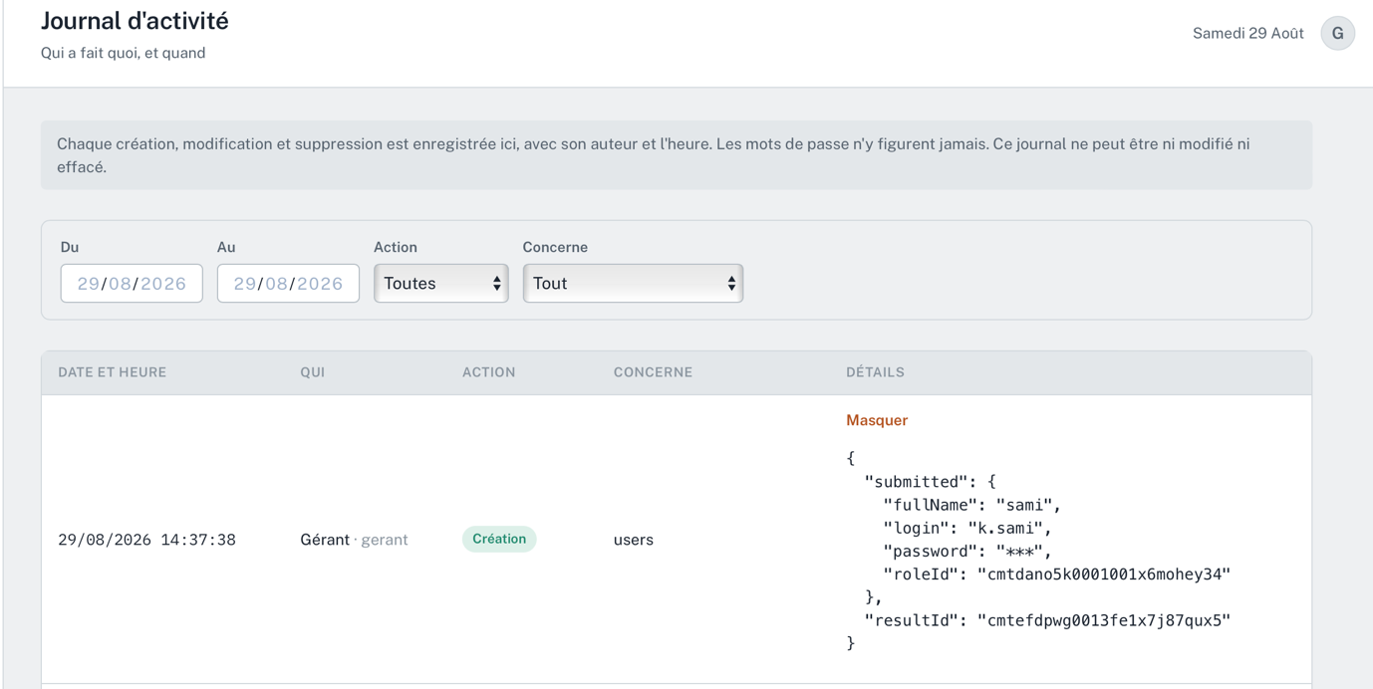

- Le retour des clients :

When a customer cancel an order “fait un retour pour qlq elemenets de produits finis” , the quantity of that order doesn’t come back to the finished products inventory ( we should work on that as well)

So the logic here is : when a client cancel and order or “fait le retour” , the user should cancel the order completely and the quantities come back to the inventory then create new order with new quantities if customer wants to continue the buying process if not the user just cancel the order

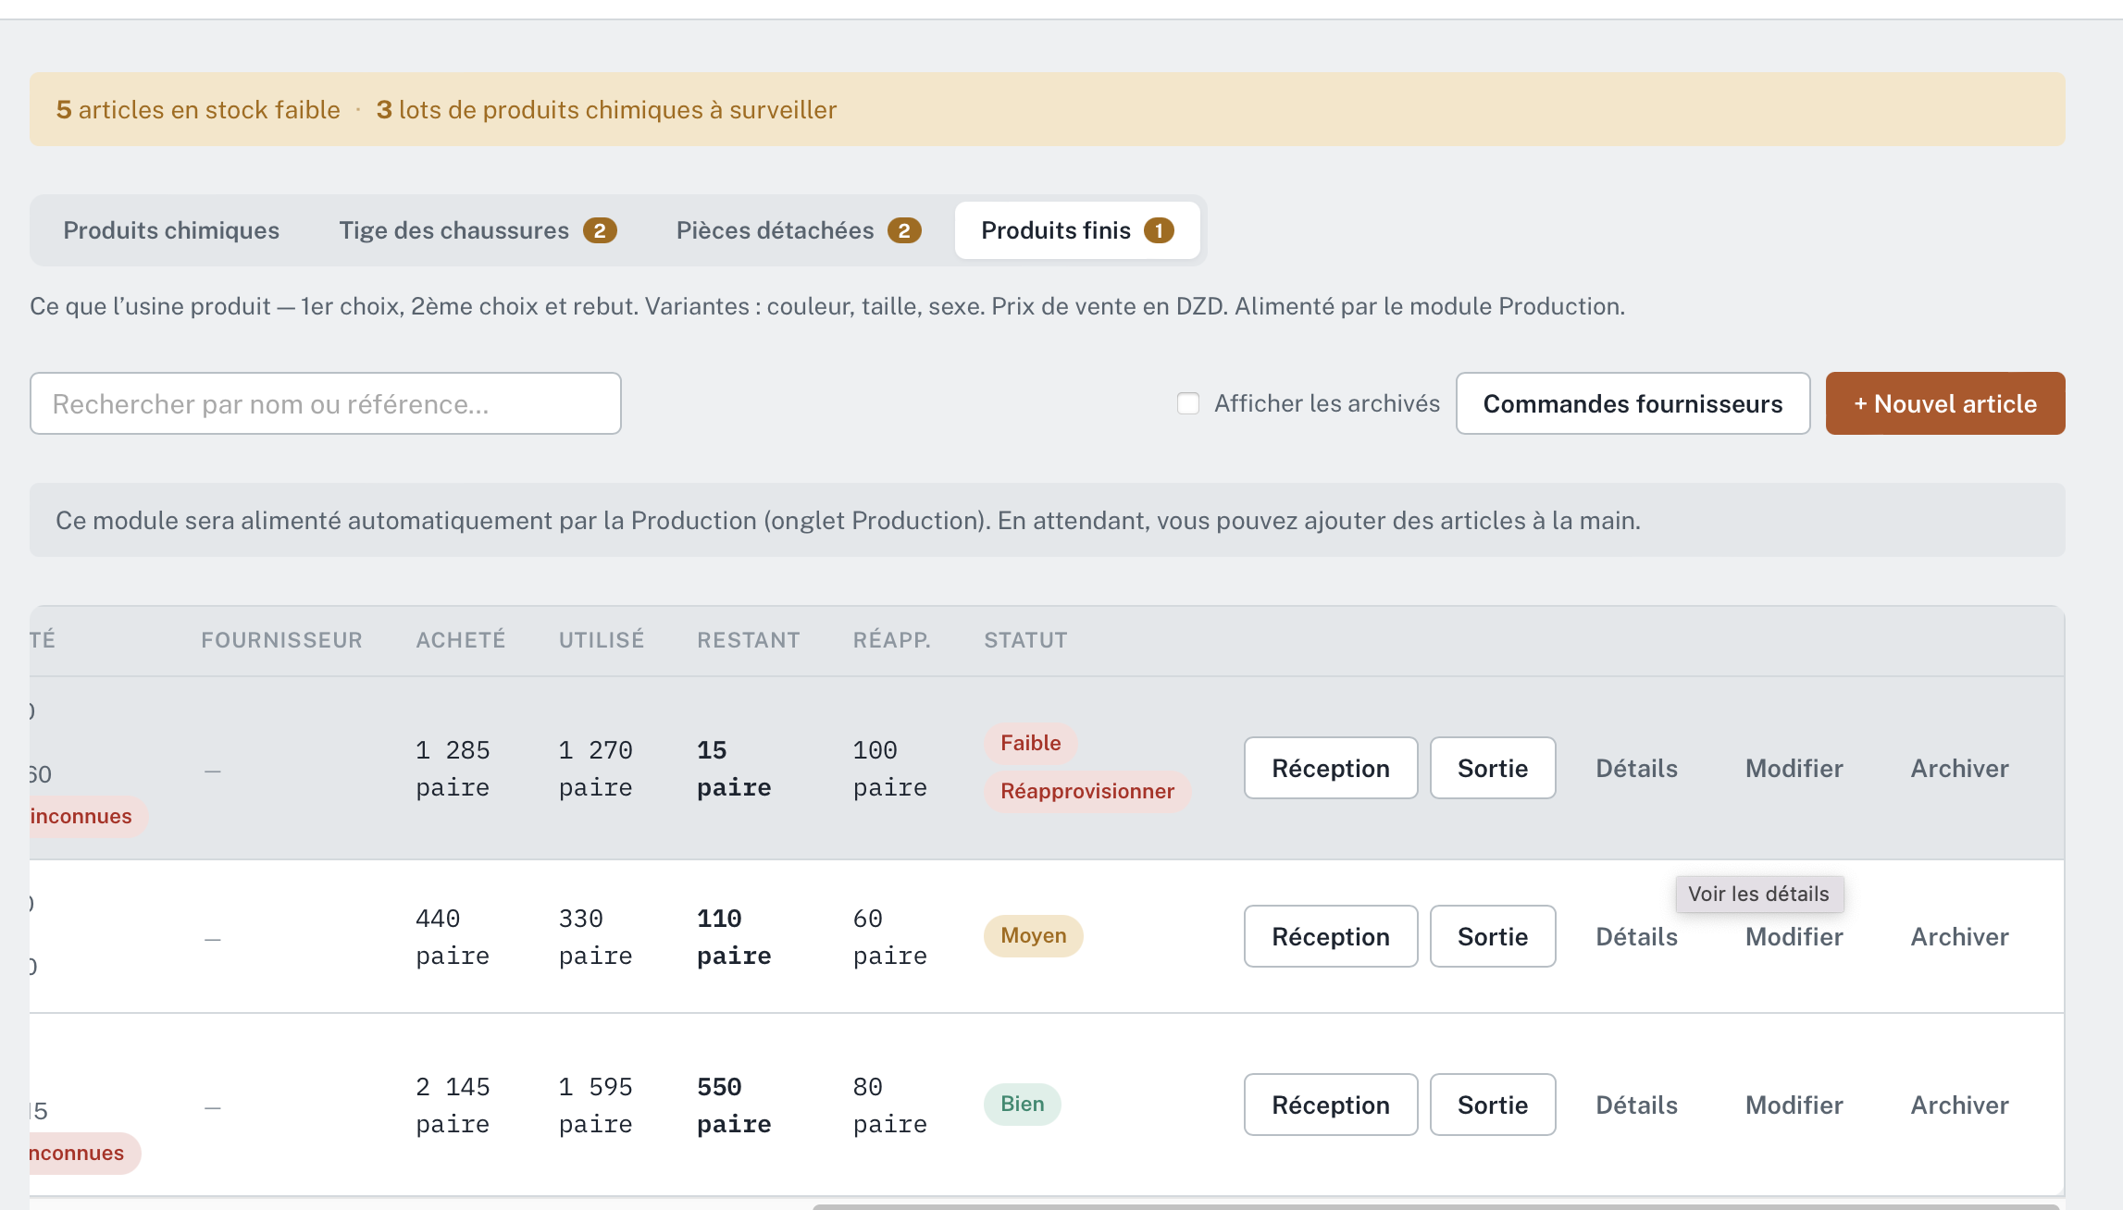

They shouldn’t be in the inventory of finished products because finished products rely directly to production.
- Error:

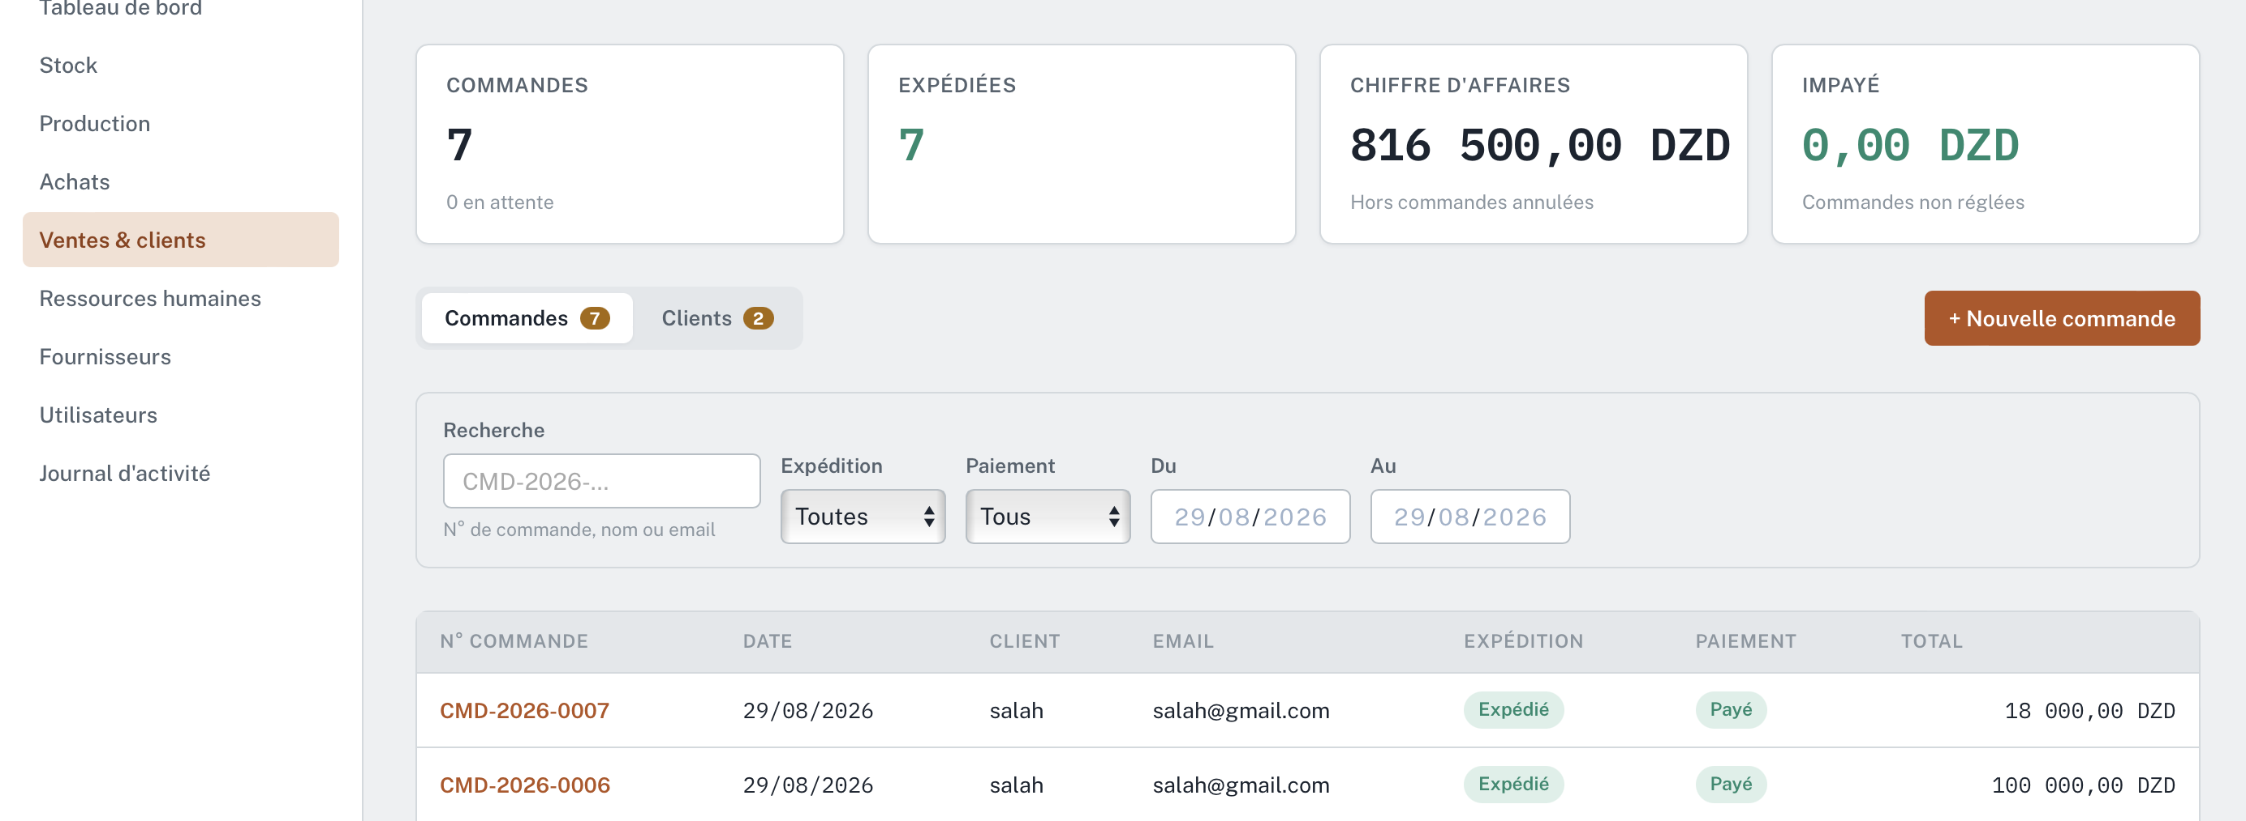

Here the revenue changes when the user adds an order and clicks on “enregistrer” even the order is not paid yet “ en attente” and that’s an error so make sure the revenue changes once the payment is done not when the user save the order and also make sure the revenue changes when the user cancel an order and that could happen if the client would cancel the order or change even after paying so add the “cancel order” icon and make sure it has a direct relationship the revenue

- Error:

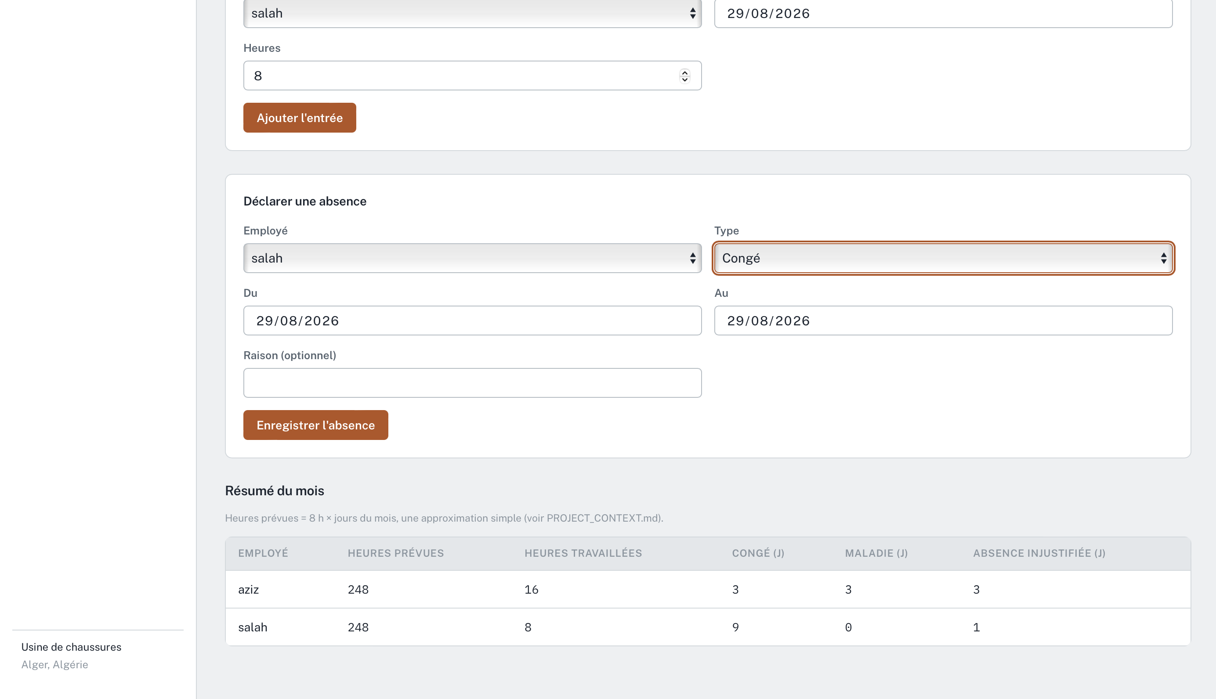
- “congé” is smth annual and couldn’t be in months so mustn’t be shown in month summary, the user can add “congé” for a specific employee just one time when the employee gets his “congé” and should appear or pop up when the user clicks on the employee to see the details
- “Maladé” also has also the same concept as “congé”
- We should add a tab in month summary called “ les heures supplementaires” in which: les heures supplémentaires = Heure travaillées – heures prévues
It shouldn’t be negative and should be auto calculated when the user type how much he gives for one extra hour

- The reason of an absence doesn’t appear in the table or should be popped up in details ?, we should fix this problem
- When it comes “declarer une absence” it should be modified in which:
. replace “ declarer une absece “ by “ absence injustifiées “
. keep employee the same
. remove type
. remove from-to and make just one date ( it will be the date of absence )
. keep reason the same

- After that add a new bar or window just right after “ absence injustifiées “ call it “congé”, the elements are:
.employee , date ( from-to)



- Remise: “achat & vente”

It should be 2 options :
- % with auto calculation
- Fixed value, the user choose it

+add donnees tab for quick exporting data from any given tab or a selection of tabs in a specific time line and other criteria options…

